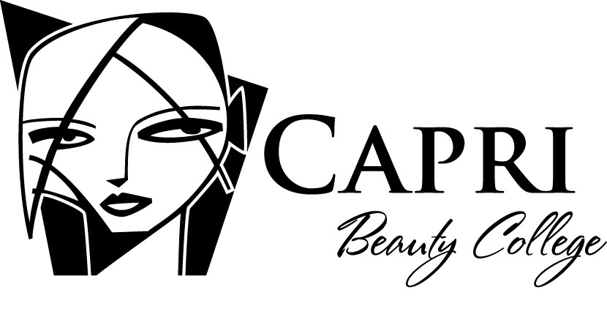
Loan Disclosures
Financial Aid Counselors are available on campus at Capri. For an appointment, contact the Admissions Department during regular business hours. Application deadline: May 1st Capri is approved by the United States Department of Education to offer the following Title IV programs for post-secondary education to eligible students:
TYPES OF FEDERAL STUDENT AID (FSA)
Federal Pell Grant: Are for undergraduate students with demonstrated financial need, as determined by federal regulations. This type of aid does not have to be repaid. Awards are based on need.
Federal Direct Loans (Subsidized): Are for students with demonstrated financial need, as determined by federal regulations. No interest is charged while a student is in school at least half-time.
Federal Direct Loans (Unsubsidized): Are not based on financial need; interest is charged during all periods, even during the time a student is in school and during grace and deferment periods.
Federal Direct PLUS Loans: Are unsubsidized loans for the parents of dependent students and for graduate/professional students. PLUS loans help pay for education expenses up to the cost of attendance minus all other financial assistance. Interest is charged during all periods.
ELIGIBILITY, AWARDING & DISBURSEMENT
Financial aid eligibility requirements:
➢➢ | Be a U.S. citizen or eligible non-citizen.
➢➢ | Hold a high school diploma, a general education diploma (GED)or a state recognized home schooled secondary completion credential.
➢➢ | Be enrolled or accepted for enrollment as a regular student working toward a certificate in an eligible program.
➢➢ | Have a valid Social Security Number.
➢➢ | Make satisfactory academic progress.
➢➢ | Register with Selective Service (males).
➢➢ | Not be in default on any student loan previously received. This also applies to parents if applying for a Federal Parent Loan (PLUS).
➢➢ | Not owe a refund or repayment on any federal grant previously awarded. Also applies to parents if applying for a Federal Parent Loan (PLUS).
➢➢ | Demonstrate financial need based on the methodology written into law by the U.S. Congress by applying for such aid on the Free Application for Federal Student Aid (FAFSA).

How is financial aid determined?
The basis of determining a student’s financial need will be an analysis of the financial status of the student’s and/or the parent’s income. This analysis is accomplished by completing a Free Application for Federal Student Aid (FAFSA) distributed by the U.S. Department of Education.
Where can you find financial aid forms?
➢➢ In your high school guidance counselor’s office.
➢➢ Via internet at capri.edu
➢➢ Via the U.S. Department of Education website - FAFSA on the Web www.fafsa.ed.gov
What factors determine financial need? ➢➢ Cost of attendance
➢➢ Expected family contribution
➢➢ Financial need
LOAN COUNSELING
Entrance Counseling
Before making the first disbursement of a loan to a Direct Subsidized or Unsubsidized Loan borrower, Capri Beauty College ensures that the student has received entrance counseling. Direct loan counseling is available on the web at: www.studentloans.gov Loan Counseling information is available at the time of enrollment, during Orientation, and delivered in a classroom setting within the first weeks of class. Financial Aid counselors are available during this process to answer questions.

Exit Counseling at the time of Separation
Students are scheduled for Exit Counseling, if available, while on campus. The Financial Aid counselor will review your student loan package, repayment schedule and estimated monthly payments. You are also scheduled to complete Exit Loan Counseling, if available, while on campus at: www.studentloans.gov The Financial Aid Office also provides Repaying Student Loans.

If the student borrower drops out without notifying the school or was not available to complete Exit Counseling on campus, Capri will confirm that the student has completed online counseling or will mail exit counseling material to the borrower at his or her last known address. It is also acceptable to e-mail the information to the borrower at his or her home e-mail address, if available. The materials are mailed or e-mailed within 30 days of learning that a borrower has withdrawn or failed to participate in an exit counseling session.

General notification: The Office of Federal Student Aid at Capri Beauty College will notify a student of the amount of funds the student and his or her parent can expect to receive from each FSA program, and how and when those funds will be disbursed via an Official Award Letter. If the funds include a Direct Loan, the notice will indicate which funds are from subsidized loans and which are from unsubsidized loans. Capri will provide the best information that it has regarding the amount of FSA program funds a student can expect to receive. Because the actual loan disbursements received by a student may differ slightly from the amount expected by the school (due to loan fees and rounding differences), the gross amount of the loan disbursement or a close approximation of the net disbursement amount will be disclosed.
Payment of Awards & Disbursement: Most funds are disbursed according to payment periods or academic award periods within in the first weeks of school. Award amounts in most cases are divided into two payment periods and will only be disbursed after the payment period has begun and only if the student is deemed to be in satisfactory progress. In the case of second payment periods, awards will be disbursed only if the student has successfully completed the appropriate number of clock hours and weeks of instruction required for the payment period. Failure to successfully complete the proper number of clock hours and weeks of instruction by the required date of evaluation may delay the next payment. To avoid delays in the payment of awards, students applying for financial assistance should make sure that all corresponding application materials, verification documents and or other financial aid related items are in to the financial aid office. Capri is not responsible for the reduction or cancellation of aid due to a student’s failure to submit required application materials or a failure to maintain eligibility standards.
The academic year must be within guidelines established by the Federal Government.
Cosmetology (1500 hours) 1-900 hours and 30 weeks 901-600 hours and 20 weeks
Teacher Training (1,000 hours) 900 hours and 30 weeks
Teacher Training (500 hours) No financial aid is awarded in this program
DISBURSEMENT BY TYPE OF FSA
Pell Grant: The earliest the Financial Aid department will request student Pell Grant funds is the day after the first day of attendance. Capri will not disburse funds prior to the start date. Capri issues books and equipment to students on the first day of class providing that all admissions and financial aid requirements are met. Books and equipment are included as part of the student’s total expected cost for the program.
Direct Student Loan: If the student or parent borrower wishes to cancel all or a portion of a loan, he or she must inform the school. A school must return the loan proceeds, cancel the loan, or do both, provided that the school receives the loan cancellation request within the following time-frames: the school obtains affirmative confirmation from the student, by the later of the first day of a payment period or 14 days after the date the school notifies the student or parent of his or her right to cancel all or a portion of a loan.
Direct Plus Loan for Parents: Generally, the loan will cover a full academic year at Capri. The College will make at least two disbursements according to the disbursement periods listed below. The disbursement of the loan money will be credited to the student’s school account to pay tuition, fees, room, board, and other authorized charges. If the loan disbursement amount exceeds your students school charges, the school will pay you the remaining balance of the disbursement directly by check or other means. In some cases, with your permission, the school may disburse some of the PLUS loan money directly to the student. Capri will issue a written receipt each time there is disburse on part of the loan and will provide information about how to cancel all or part of the disbursement if the money is no longer needed. You will also receive a notice from the U.S. Department of Education confirming the disbursement. You should read and keep all correspondence received concerning your loan. Additional Information on Direct Plus Loans is available at: http://www.direct.ed.gov/parent.html
Disbursement Periods: In most cases disbursements are made over two or more payment periods.
The 1st disbursement covers 1 - 450 clock hours (Cosmetology, Teacher Training 1000 hrs)
The 2nd disbursement covers 451 - 900 clock hours (Cosmetology, Teacher Training 1000 hrs)*
The 3rd disbursement covers 901-1200 clock hours (Cosmetology)*
The 4th disbursement covers 1201-1500 clock hours (Cosmetology)*
*In order to be eligible to receive multiple disbursements, students must have remaining eligibility for funds during the payment period of that award year.

Credit Balance: If Federal Student Aid disbursements to the student’s account create a credit balance, the Office of Federal Student Aid at Capri Beauty College will mail a check payable to the student or parent (in the case of a PLUS Loan) no later than 14 days after credit balance occurred.
Holding FSA funds on behalf of the student: With written authorization from a student, Capri may hold, on behalf of the student,
FSA funds that would otherwise be paid directly to the student

National Student Loan Data System
Notice to potential students, current students and/or parent/s of a student who enter into an agreement with Capri Beauty College regarding a Title IV, HEA loan: Capri is required to submit the loan to the National Student Loan Data System (NSLDS), which will be accessible by guaranty agencies, lenders, and schools determined to be authorized users of the data system.

Self Certification – Truth in Lending Act: The applicant may obtain a copy of the self-certification form from the private lender and submit it to the school for completion or confirmation.

